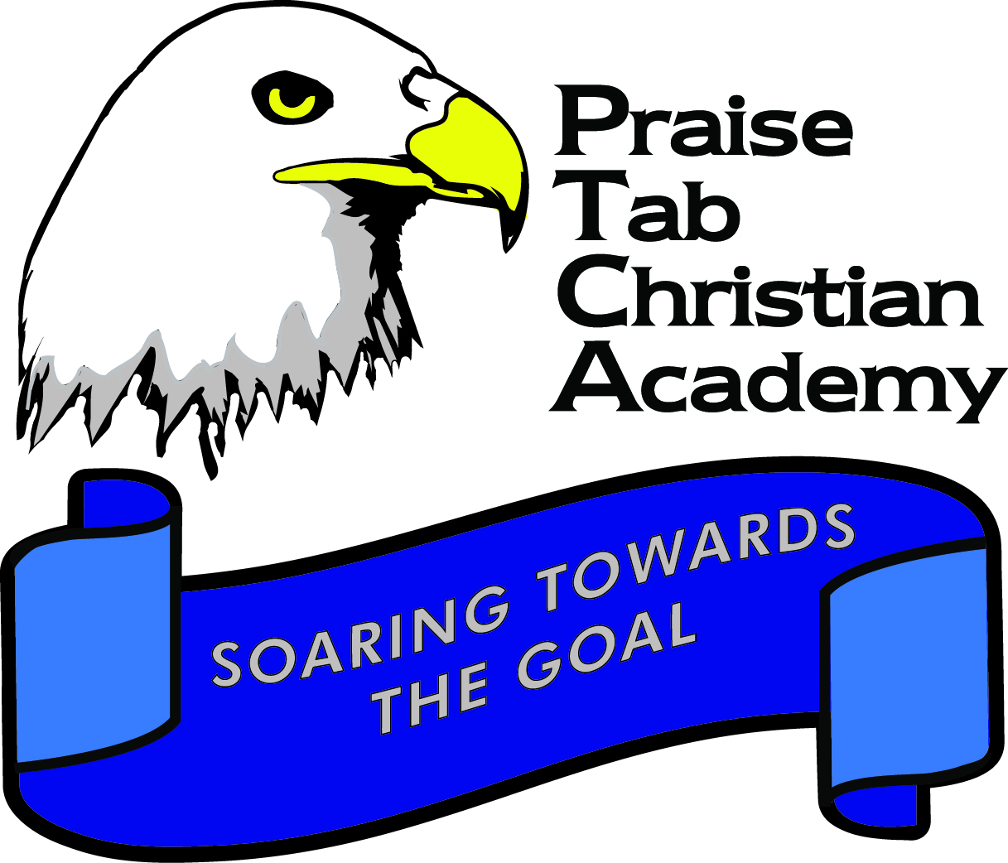
PRAISE TAB. CHRISTIAN ACADEMY
CALENDAR FOR SCHOOL YEAR 2019/2020

Attention: Parents/Guardian
Please take note of the following schedule for activities/events during the school year 2019/2020
FIRST TERM – CHRISTMAS TERM (2019)
Deadline for Submission of School Fee Vouchers August 30, 2019
Please note: Admission to class is dependent on
bank voucher being submitted to office.

Teachers’ Seminar (school reopens for all teachers) August 26
Orientation: K2 – K5 August 27 (8:00 a.m.)
Orientation: Grades 1 - 3 August 28 (8:00 a.m.)
Orientation: Grades 4 – 6 August 29 (8:00 a.m.)
School re-opens for Grade 1 August 30
(Grade One Individual Learning Profile Exam) (All Teachers to be present)
School re-opens (all teachers) September 2
School re-opens (all students) September 3
Miss Lou Day September 6
*** Dress code:
- Boys: Bandana top, uniform pants, black shoes and blue socks
- Girls: Bandana outfit with white sneakers and white socks.

Dedication Service (all students and staff) September 8 @ (8:30am)
Venue: Praise Tabernacle
14 Sandringham Avenue, Kingston 10
Back to School Night (Grades 4 – 6) September 16 @ 5:30 p.m.

Back to School Night (Grades 1 – 3) September 18 @ 5:30 p.m.

Back to School Night (K2 – K5) September 19 @ 5:30 p.m.

National Heritage Week Celebrations October 18
(Each student is asked to give a contribution of $200 on same day)
*** Dress code for this day:
- Boys: Bandana top, uniform pants, black shoes and blue socks
- Girls: Bandana outfit with white sneakers and white socks.

National Heroes Day (NO CLASSES) October 21
Classes Resume October 22
Parents/Teacher Conference November 19
(No classes. Students should accompany parents)
Production Day Pending
School Ends December 17
School re-opens: January 6

SECOND TERM – EASTER TERM (2020)
School re-opens (all teachers) January 6
School re-opens (all students) January 7
Jamaica Day February 28
(Each student is asked to make a contribution of $200. 00)
Parents are welcome to celebrate with us.
*** Dress code for Jamaica Day- Students wear
(black, green, gold with Jeans bottom).

PEP: Ability Test (Grade 6 – Ministry) February 25
Ash Wednesday (School closes) February 26
School Resumes February 27
Sports Day Pending
Early Childhood Age 4 Assessment March 11
(Assessment ends April 8)
PEP: Grade 6 CBT (Ministry) March 19 – 20
**Registration for all in-house Competition Opens March 25
School Term Ends April 8
THIRD TERM – SUMMER TERM - 2020
School re-opens (all teachers) April 20
School re-opens (all students) April 20
PEP: Grade 6 Performance Task (Ministry) April 23 – 24
**Registration for all in-house Competition Closes April 30
In-house Competitions begins May 4
Teacher’s Day May 6
(No aftercare & school dismisses @ 1pm)
Fun Day May 22
Labour Day (School Closes) May 25
School Resumes May 26
Grade 5 Performance Task (Ministry) May 26 – 29
Prize Giving K2 & K4 June 5(7:15-8:00 a.m.)
Prize Giving Grades 1 & 2 June 6(7:15-8:00 a.m.)
Prize Giving – Grade 5 June 7
Grade 3 Diagnostic Test June 11 – 12
Prize Giving Grades 3& 4 June 13(7:15-8:00 a.m.)
Banquet (Grade 6) June 13
K3 Graduation and Prize Giving June 14(7:15-8:00 a.m.)
Fun Day June 14 (School closes)
Banquet (Kindergarten 5) June 17
Graduation (Grade 6) June 18
Graduation (Kindergarten 5) June 19
PEP: Grade 4 Performance Task (Ministry) June 25 – 26
Summer School July 1 - July 19
The 2019/2020 school year August 26

